**RIP (version 2) Configuration in Cisco Packet Tracer**

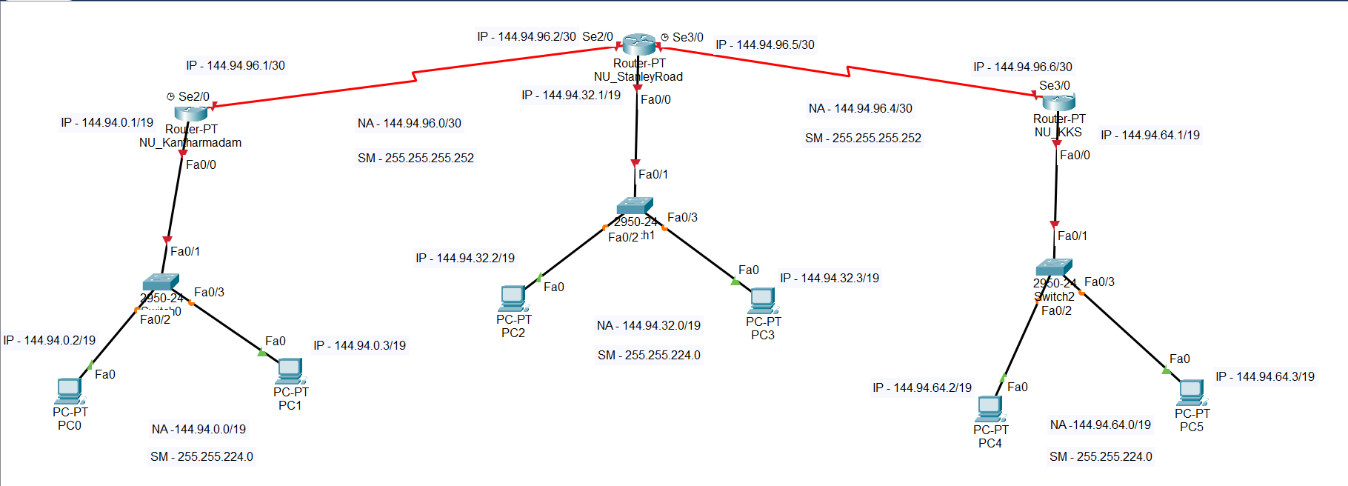

**IP Address Configuration for NU_Kantharmadam**

interface FastEthernet0/0

ip address 144.94.0.1 255.255.224.0

no shutdown

interface Serial2/0

ip address 144.94.96.1 255.255.255.252

clock rate 64000

no shutdown

**IP Address Configuration for NU_StanleyRoad**

interface FastEthernet0/0

ip address 144.94.32.1 255.255.224.0

no shutdown

interface Serial2/0

ip address 144.94.96.2 255.255.255.252

no shutdown

interface Serial3/0

ip address 144.94.96.5 255.255.255.252

clock rate 64000

no shutdown

**IP Address Configuration for NU_KKS**

interface FastEthernet0/0

ip address 144.94.64.1 255.255.224.0

no shutdown

interface Serial3/0

ip address 144.94.96.6 255.255.255.252

no shutdown

Use **show ip route** to view the current IP routes available where you’ll see only the directly connected networks.

**RIP Configuration for NU_Kantharmadam**

router rip

version 2

no auto-summary

network 144.94.0.0

network 144.94.96.0

**RIP Configuration for NU_StanleyRoad**

router rip

version 2

no auto-summary

network 144.94.32.0

network 144.94.96.0

network 144.94.96.4

**RIP Configuration for NU_KKS**

router rip

version 2

no auto-summary

network 144.94.64.0

network 144.94.96.4

Use **show ip route** to view the current IP routes available where you’ll see both the directly connected networks and indirectly connected networks.

**IP Route for NU_Kantharmadam**

